Customer(RAS) is getting an error message when they hit edit config after they submit a configuration for the Roller Shades (Operational, Dual, Linked) configurator.
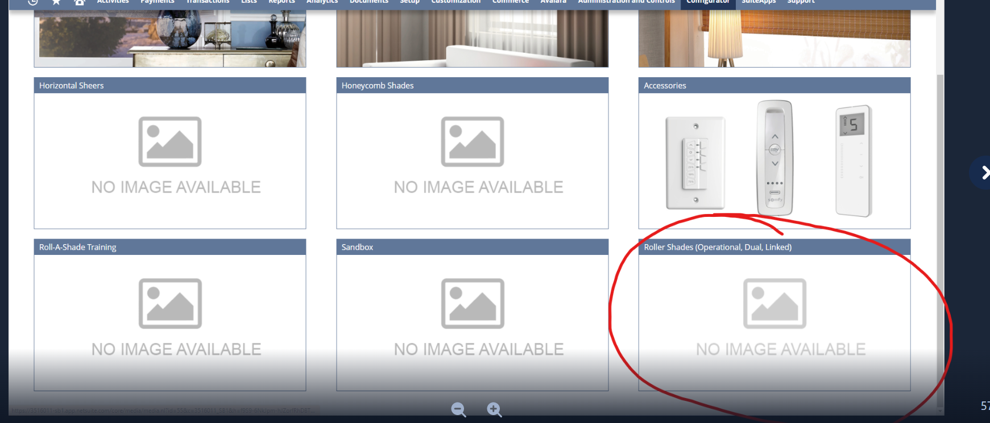
RAS saved an opportunity called “Edit Config Not Working C15638 Blinds 4 Less” that already has an assembly set as the line item to test out the error.
There is also a favorite called “First Fav“ that has been saved that can be used to test out the error message.
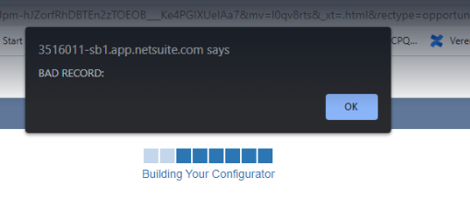

Repro steps
Search for the “Edit Config Not Working C15638 Blinds 4 Less“ Opportunity in the Global Search box. Once you find it, click on Edit and then scroll to the bottom and click on the line item and then click on Edit Config:
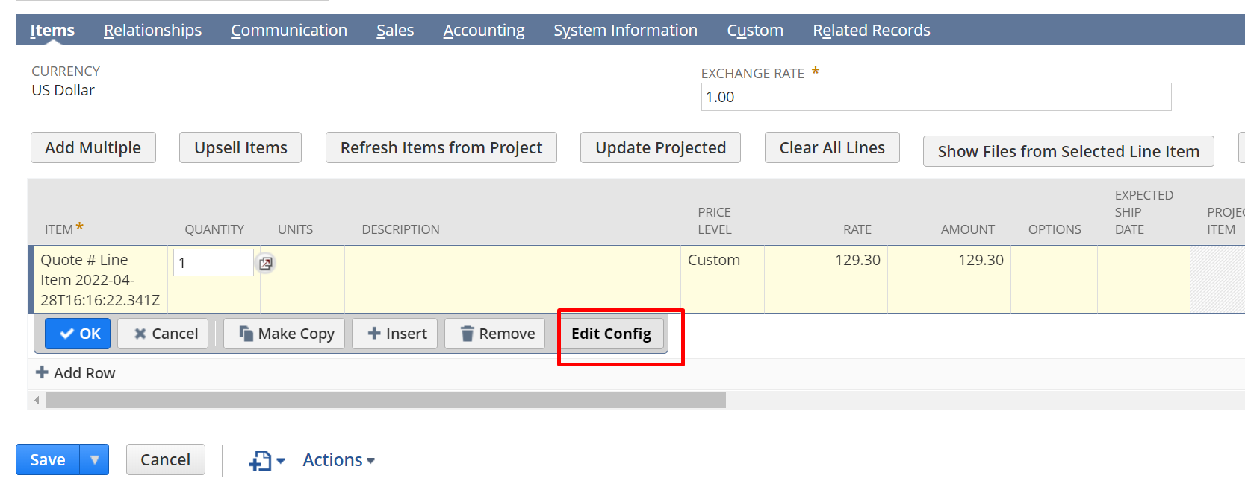
If i press that, I get this:
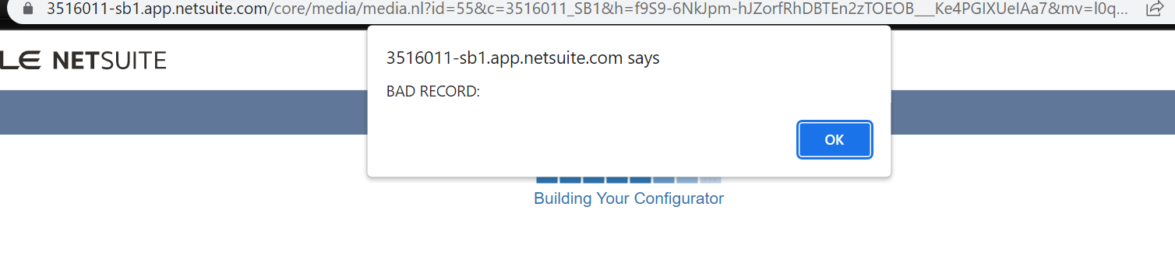
Then, go back to opportunity and press configure:
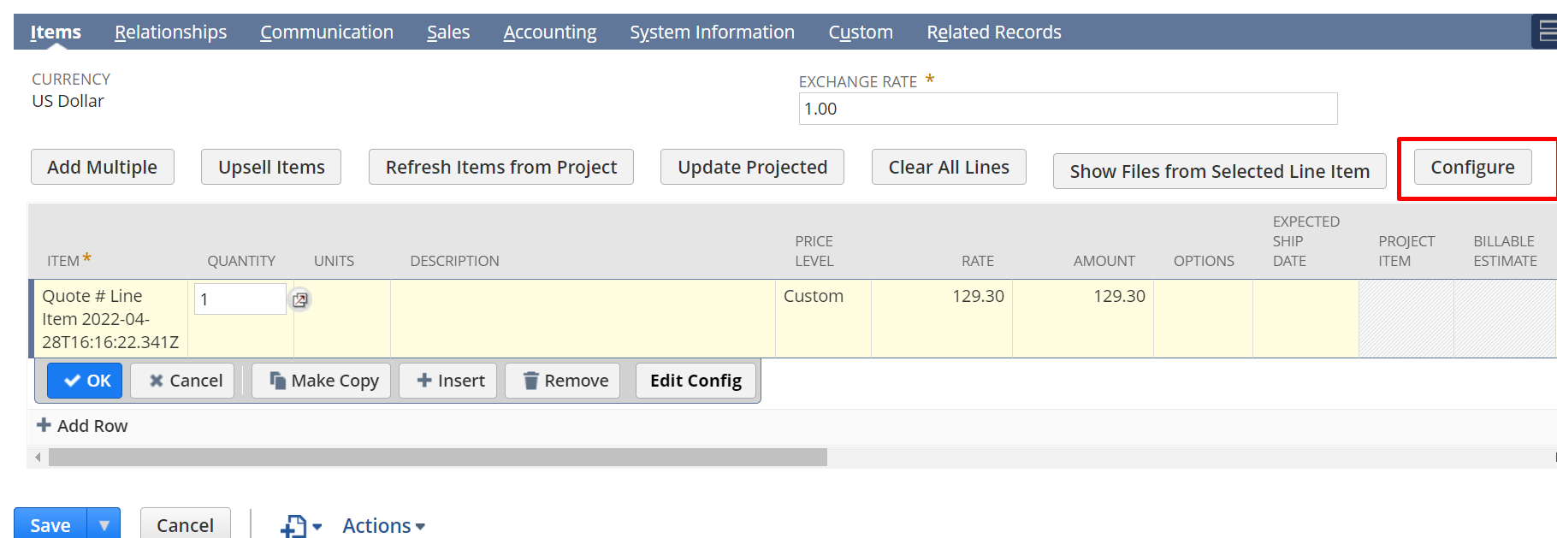
Then Roller Shades (operational, dual, linked):
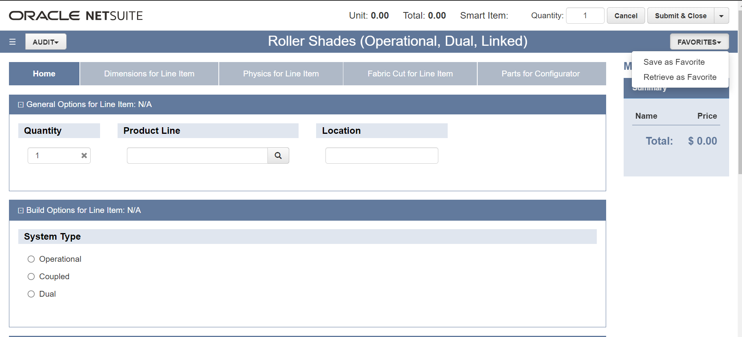
Press on the top right “Favorites -> Retrieve as Favorite” luego presiono en show all y en retrieve:
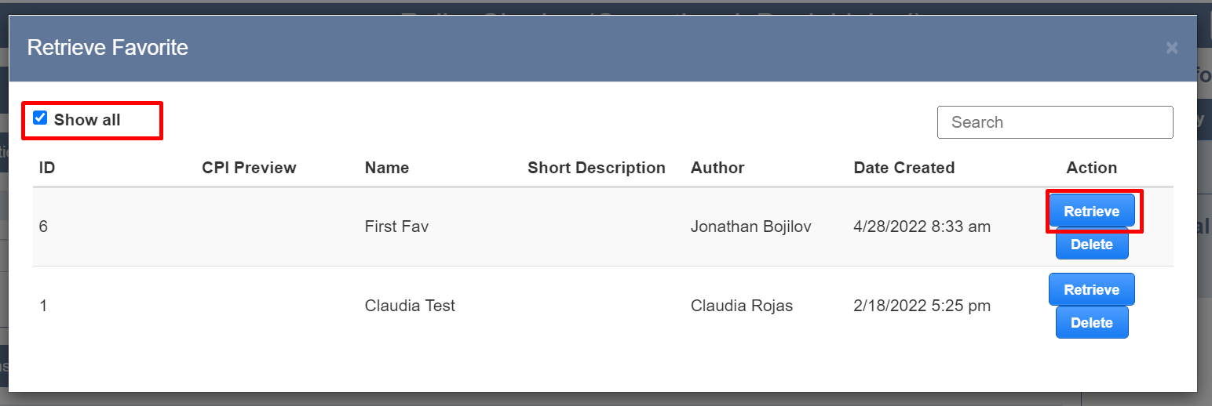
Y me va a dar unos errores:
“Cannot redefine property: HEMBAR_WT_OZ_PER_FT”
Tengo que buscar esto en: Configurator -> Product -> Product Mantainance: Elijo Roller Shades (Operational, Dual, Linked) -> Actions y elegir global variables.

How was the configuration example submitted for Roller Shades (Operational, Dual, Linked) configurator

The usual reason for this is that the item record, you are trying to edit config for, the line item record, doesn't have the 'IS CONFIGURABLE' field set to true and does not have the SCPQ product configurator set.
Open the opportunity, and look for the line item:
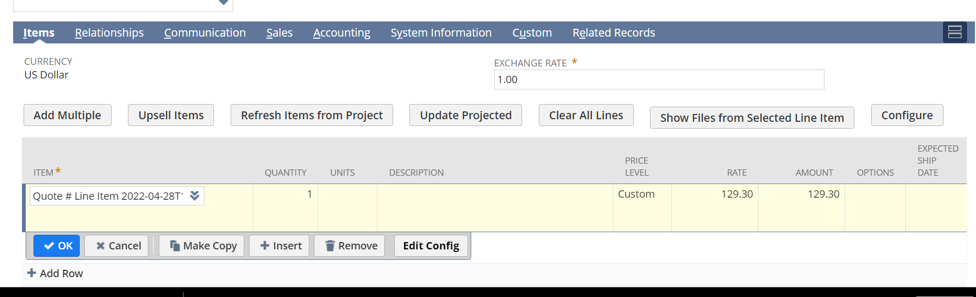
Then open the page of the item and look for this:
On custom tab:
